Name (Student Number) | Edy Nastase (24256882), Shane Kennedy (24252940), Zeiad Elmallah(20739091)
Module | 2425 – CT5170 Principles of Machine Learning - Online
Assignment | Assignment 3 - Advanced Classification and Clustering of Health Conditions
Due Date | December 1st 2024

Contributions of Candidates

- Throughout the assignment all 3 candidates connected via both WhatsApp and Teams to discuss roles and responsibilities and progress through the assignment
- It was agreed that all three of us would attempt the assignment individually before meeting to discuss
- During our first meeting we talked through the work each of had done, progress made, challenges and next steps
- It was evident at this stage that Edy had made more progress on Clustering while Zeiad and Shane had progressed further on Classification
- We all had attempted to fit different models and different ways of dealing with the class imbalance issue
- It was agreed at this stage that we would share the work we had done via the Group section on Canvas for us to review and assess
- Some of us had done coding on different platforms (e.g., Jupyter Notebook or PyCharm). We agreed that the final code submission would be contained in Jupyter Notebook
- We also agreed that Shane & Zeiad would review and provide feedback to Edy on Clustering work done, Edy would do the same on Classification, Zeiad would finalize the Data Exploration section (using information from all 3 of us), Shane would collate all results into a word document report. Then we would connect to finalize the last section together (Comparative Analysis and Reporting)
- Edy shared commentary on Density-Based Spatial Clustering of Applications with Noise (DBSCAN) and Gaussian Mixture Models for Clustering, Shane on K-Nearest Neighbors (KNN) and Random Forest for Classification, and Zeiad on Decision Trees for Classification.
- We all reviewed the work carried out by each other before agreeing what information should be included in the final submission
- One Jupyter Notebook was created, combining the key elements of the work done
- This report was also finalized, incorporating the best performing models we had developed, ensuring we had 2 for Classification and 2 for Clustering. We also included commentary which best represented our collective views and assessments

Understanding the Dataset (1 Mark)

- The data train-3.csv is made up of binary examples of different diseases/symptoms that gave 1 of 4 diagnoses in column TYPE (COVID, ALLERGY, FLU, COLD).
- There is not much room for outliers in this dataset as it is all binary, however there is an issue with the counts of each TYPE where the percentage makeup of them is not even leading to potential future bias in the models as it would lean towards the larger TYPE’s
- After we investigated different methods to alleviate this issue, we found that under/overfitting may be what we needed to fix this problem, after looking deeper we also found another method that combines the 2 that can be seen later.

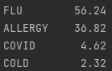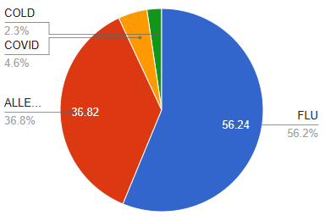

Classification (3.5 Marks)

Model 1: Decision Tree
- The decision tree classifier organizes data like a binary search tree. For example, with features like height and weight to decide pilot eligibility, it splits data at the root (e.g. fever), with branches for "no" or further checks (e.g. nausea). Basing outcomes are on threshold comparisons.
- We tested the algorithm for different types of fitting and the best one was using a mix of both under/overfitting using Synthetic Minority Oversampling Technique (SMOTE & SMOTEENN) to address the problem of class imbalance
- We also tested various hyperparameters through grid search (max depth, min samples split, min samples leaf) iteratively changing the values that grid search would use to get a more detailed insight on what worked the best for this data set.
- Additionally, one of the benefits of using a simple algorithm like Decision tree for any dataset is that it is easy to visualize and provide insights
- The Accuracy is 92.47% the confusion matrix showed as indicated in the Tree that there are some Types that worked well like Flu and Allergy at the cost of the other 2 which is what can be expected

Model 2: Random Forest
- Random Forest is also a supervised learning method and can be used for classification and regression problems. Random Forests work well with large and complex datasets, and high-dimensional feature spaces. It is an ensemble algorithm where a set of decision trees are created from a randomly selected subset of the training set. For classification problems, it collects the votes from all the decision trees and the final prediction is based on the majority vote.
- This approach, known as bagging (Bootstrap Aggregation), prevents dominance of any single feature and reduces overfitting resulting in a more robust model. When creating the decision trees, the best feature at each node point is selected based on a given criteria (gini, entropy, log_loss). Gini is used for the purpose of this exercise since it is computationally simpler and faster to calculate due to its linear characteristics.
- In the data pre-processing step, we used Synthetic Minority Oversampling Technique (SMOTE) to address the problem of class imbalance. SMOTE is specifically designed to tackle imbalanced datasets by generating synthetic samples for the minority class.
- Grid search was then used to select the best hyperparameters for max depth and number of estimators. A visual displaying the Accuracy for various combinations of these hyperparameters is shown below.
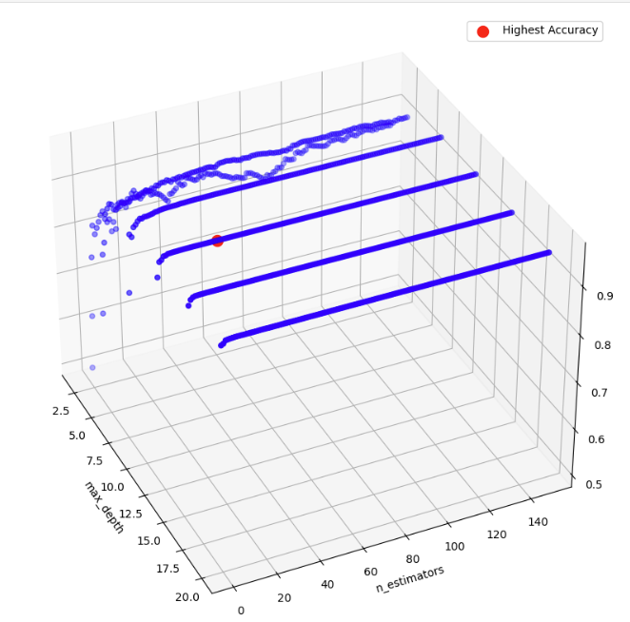
- When the hyperparameters were selected, the model was evaluated, calculating metrics such as Accuracy, Precision, Recall, F1 and Area under the Curve (AUC). A confusion matrix was also created.
- Accuracy, Precision, Recall and F1 was 0.96. AUC was 0.99.
- As expected, the Random Forest performed stronger than both KNN and Decision Tree.

Comparison of results
Decision Tree: Confusion Matrix | Random Forest: Confusion Matrix
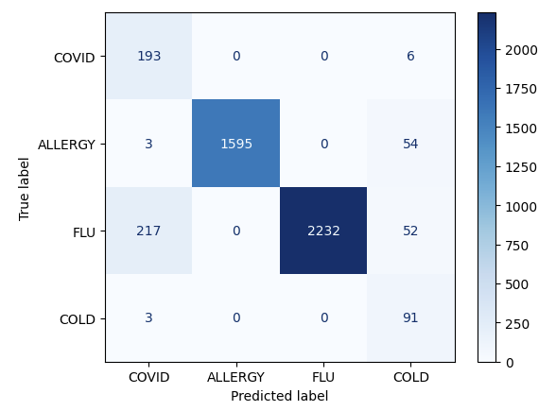 | 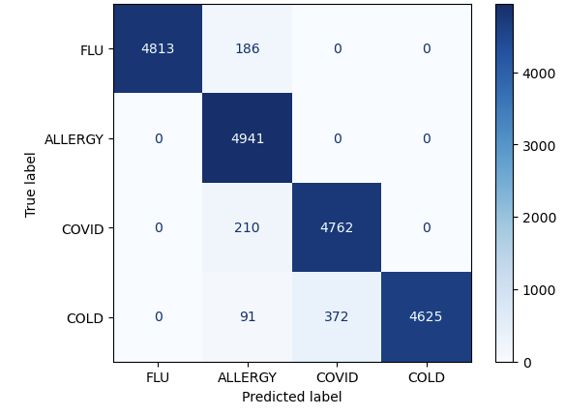

Decision Tree: Classification Report | Random Forest: Classification Report
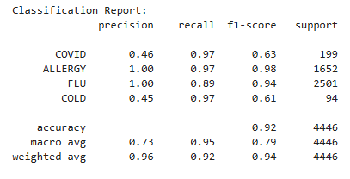 | 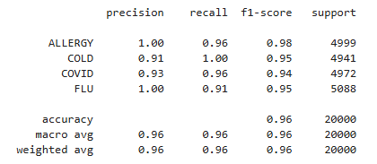

Cluster Evaluation (3.5 Marks)

UMAP (Uniform Manifold Approximation and Projection) – Dimensionality Reduction technique used
The decision of using Uniform Manifold Approximation and Projection (UMAP) comes from the fact that Principal Component Analysis (PCA) only works well with the first 2 components. In the given context, the PCA algorithm behaves poorly and cannot account for enough variance within the first two Principal Components (PCs). UMAP is a fast algorithm (even with high dimension data) that can perform dimension reduction that results in clearly separated clusters.

First, UMAP calculates similarity scores in the higher dimension using a distance/similarity metric. Since the data is binary, the UMAP algorithm will use hamming distance, which represents the number of “errors” between two sets of bits (i.e. the number of flips from one set of bits to another). The distances will be calculated from each point to all the other ones.

Second, UMAP takes each point from the high-dimension and places it in a lower dimension representation (based on the number of components; usually 2). In the lower dimension, all the other points will be at the distance calculated by the hamming score in the higher dimension from the selected point. To calculate similarity within the lower dimension, UMAP uses a curve that calculates similarities. This curve depends on the number of neighbors (arguably the most important parameter in UMAP; usually set to 15) that each point considers when calculating the similarity score. This curve will follow $log_{2}({neighbours)}_{}$where each point in the lower dimensionality will have a corresponding y-axis value on the similarity score. All these y-axis points will have to add up to the value of $log_{2}({neighbours).}_{}$The lower dimensionality similarity score calculation will be repeated for each point from the higher dimension. The points that are close based on the similarity score will end up in the same cluster.

Third, it is not enough to calculate the similarity score in the lower dimension for UMAP to create clearly defined clusters. An important aspect will be how close each point will be to the other points within its cluster and how far it will be from the points in other clusters. UMAP will randomly pick two points in the lower dimensionality that have a high similarity score and it will decide randomly whether to bring the first point closer to the second, or the second closer to the first point. After deciding which point is being moved closer, a different random point from a separate cluster is picked to move away further from. UMAP will use two t-distributions with the center (mean) of each being specified by the points that you want to move closer to and further away from. The selected point will be moving closer to the t-distribution mean of the point it wants to move closer to and further away towards the tails of the other t-distribution for the point it wants to move further away from. It essentially, maximizes and minimizes the lower dimensionality similarity scores. This will be repeated for all points, and the result will be a clearly defined cluster. Note, that this procedure of moving the points closer and further away is sequentially for each point (not like in t-distributed stochastic neighbor embedding where all points are moved at once).

Model 1: Density-Based Spatial Clustering of Applications with Noise (DBSCAN)
DBSCAN is controlled by two key hyperparameter, namely, “eps” that defines the radius around each point to check for neighbors, and “min_samples”, that specifies how many points must be within that radius to form a dense region. The algorithm will classify each point into three categories:
- Core points, which must have at least min_samples points within the specified eps range
- Border points, that fall within the eps radius of a core point, but do not have enough neighbors
- Noise points, that are not within the eps radius of a core point and do not have enough neighbors
It is crucial to note that cluster formation happens sequentially. When DBSCAN identifies a core point, it creates a new cluster containing that point and all the other points within its eps radius. Then it will explore the neighborhood of each core point in the cluster, expanding until no more connected points can be found.

Model 2: Gaussian Mixture Model (GMM)
Gaussian Mixture Models (GMM) represent a more advantageous approach to clustering compared to K-Means by using “soft clustering”. Instead of assigning points to specific clusters like K-Means “hard-clustering” methodology, GMM uses Gaussian probability distributions to calculate the likelihood of each point belonging to each cluster. The algorithm initializes random Gaussian distributions (equal to the number of clusters you are looking for) with random means (center), variances (spread) and covariances (shape and orientation) and mixing coefficients (probabilistic importance of each cluster). Using the Expectation-Maximization process (also followed by K-Means), it calculates the probability of each point being part of each distribution, then it updates Gaussian distributions’ parameters based on these probabilities. This process will be repeated until the model converges.

There are two important ways of evaluating clustering methods, namely, silhouette score and adjusted rand index.
- Silhouette score represents a metric that evaluates how similar a point is from its own cluster when compared with other clusters. The range is from -1 to 1, where 1 means that the selected points are well-matched within their assigned cluster, 0 refers to overlapping clusters and -1 represents the worst value. The silhouette score for one data point will first calculate the average distance between the selected point and all the other points within the same cluster (intra-distance). Then, it will calculate the average distance between the mean nearest cluster distance and the selected point.
- Adjusted Rand Index (ARI) is a different type of clustering metric that measures the similarity between two clusterings of the same data set. Given that the true labels are available, ARI can be used to compare how good the clustering methods (GMM and DBSCAN) are in achieving the true clusters.

Comparison of results

Metric | DBSCAN | Gaussian Mixture
Silhouette Score | 0.7611177 | 0.5688359
Adjusted Rand Score | 0.7366948 | 0.5299489

DBSCAN: True Clusters | Gaussian Mixture: True Clusters
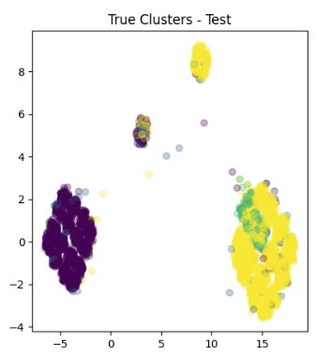 | 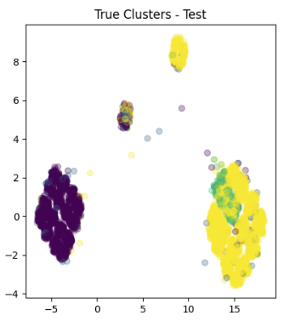

DBSCAN: Predicted Clusters | Gaussian Mixture: Predicted Clusters
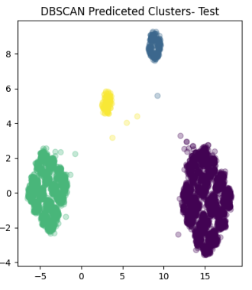 | 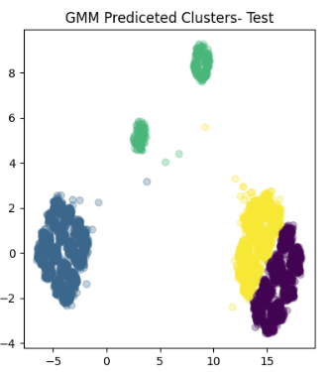

Comparative Analysis and Reporting (2 Marks)

Decision Trees are useful for classification due to their simplicity, interpretability, and relatively low computational time. However, they are prone to overfitting. Random Forests are ensemble methods, based on multiple decision trees, which can reduce the risk of overfitting. They are often more robust and accurate. However, they are more complex and computationally intensive. This can be challenging especially when tuning hyperparameters as in this exercise.

In this exercise we see that the Random Forest performed better than the Decision Tree as expected, producing an Accuracy, Precision, Recall and F1 score of 0.96 and Area under the Curve of 0.99.

DBSCAN has various advantages over GMM for clustering such as identifying clusters without specifying a shape (spheres, Gaussian distributions), works without specifying the number of clusters and can handle noise well. GMM has its own advantages in clustering such as uses probabilistic assignment instead of hard assignments and allows you to specify the number of clusters. It is important to note that there is no “better” clustering method, but a more “suitable” one, that can be based on a specific metric.

In the exercise we see that DBSCAN outperforms GMM, showing a higher silhouette score (0.76), which indicates that the clusters developed by DMSCAN are of a higher quality than those developed by GMM. DBSCAN clusters are more well defined and distinct from each other than GMM clusters.

APPENDIX

Bibliography
Anon., n.d. Clustering. [Online]
Available at: https://scikit-learn.org/1.5/modules/clustering.html
Anon., n.d. DecisionTreeClassifier. [Online]
Available at: https://scikit-learn.org/stable/modules/generated/sklearn.tree.DecisionTreeClassifier.html
Anon., n.d. Gaussian Mixture. [Online]
Available at: https://scikit-learn.org/1.5/modules/generated/sklearn.mixture.GaussianMixture.html#sklearn.mixture.GaussianMixture
Anon., n.d. rapidtables. [Online]
Available at: https://www.rapidtables.com/tools/pie-chart.html
Anon., n.d. SMOTEENN. [Online]
Available at: https://imbalanced-learn.org/stable/references/generated/imblearn.combine.SMOTEENN.html
Anon., n.d. umap. [Online]
Available at: https://umap-learn.readthedocs.io/en/latest/
Coşgun, H. H., 2023. which-data-scaling-technique-should-i-use. [Online]
Available at: https://medium.com/@hhuseyincosgun/which-data-scaling-technique-should-i-use-a1615292061e
[Accessed 10 2024].
datacarpentry, 2024. starting-with-data. [Online]
Available at: https://datacarpentry.org/python-ecology-lesson/02-starting-with-data.html
[Accessed 2024].
Jain, A. K., 2010. Data Clustering: 50 years beyond K-Means. pp. 651-666.
Martin Ester, H.-P. K. J. S. X. X., n.d. A Density-Based Algorithm for Discovering Clusters. [Online]
Available at: https://www.dbs.ifi.lmu.de/Publikationen/Papers/KDD-96.final.frame.pdf
Patlolla, C. R., 2018. Towards Data Science. [Online]
Available at: https://towardsdatascience.com/understanding-the-concept-of-hierarchical-clustering-technique-c6e8243758ec
Pedregoza, 2011. Scikit-learn: Machine Learning in Python. [Online]
Available at: https://jmlr.csail.mit.edu/papers/v12/pedregosa11a.html
Shalizi, C., 2009. DistancesbetweenClustering,Hierarchical. [Online]
Available at: https://www.stat.cmu.edu/~cshalizi/350/lectures/08/lecture-08.pdf
Yang, L. L. L. H. P., 2023. Using Medical Data and Clustering Techniques for a Smart Healthcare System. Multidisciplinary Digital Publishing Institute, Issue https://www.mdpi.com/2079-9292/13/1/140#:~:text=The%20clustering%20technique%20is%20one,a%20hospital%20for%20medical%20treatment..

